Assignment-Chapter 9&10 (100 points)

Student Name: Hannah Roach ID:678363897

1. Please run the following two commands and observe the differences of two graphs. Write the difference and the reasons. (10 points)

a. p <-ggplot(heightweight,aes(x=ageYear,y=heightIn)) +geom_point()

p + theme(axis.title.x =element_text(colour="red")) + theme_bw()

b. p + theme_bw() + theme(axis.title.x =element_text(colour="red",size=12))

With the first graph (a.), the default theme (theme_bw()) is written after the custom theme (theme(axis.title.x =element_text(colour="red"))). This causes the default theme to overwrite the custom theme. As a result, the x-axis is black.

In the second graph (b.), the default theme is written before the custom theme. This causes the custom theme elements to overwrite the default theme elements. As a result, the x-axis is red.

1. Use the PlantGrowth data frame to draw following graphs, respectively. Write down the used functions in ggplot2 (25 points)

(a)

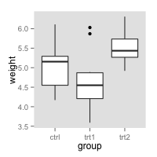

(b)

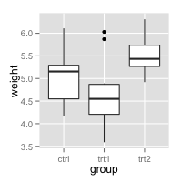

(c)

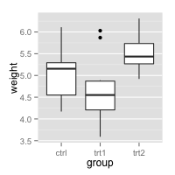

(d)

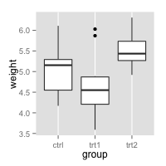

Answers:

a.

ggplot(PlantGrowth, aes(x = group, y = weight)) + geom_boxplot() +

scale_x_discrete(limits=c("ctrl", "trt1", "trt2")) +

theme(panel.grid.minor = element_blank(), panel.grid.major = element_blank())

b.

ggplot(PlantGrowth, aes(x = group, y = weight)) + geom_boxplot() +

scale_x_discrete(limits=c("ctrl", "trt1", "trt2")) +

theme(panel.grid.minor = element_blank())

c.

ggplot(PlantGrowth, aes(x = group, y = weight)) + geom_boxplot() +

scale_x_discrete(limits=c("ctrl", "trt1", "trt2")) +

theme(panel.grid.minor.x = element_blank(), panel.grid.major.x = element_blank())

d.

ggplot(PlantGrowth, aes(x = group, y = weight)) + geom_boxplot() +

scale_x_discrete(limits=c("ctrl", "trt1", "trt2")) +

theme(panel.grid.minor.y = element_blank(), panel.grid.major.y = element_blank())

1. Please use the DF1 data frame to draw following graphs, respectively. Write down the used functions in ggplot2 (40 points)

DF1 <- data.frame(x = 1:10, y = 1:10, gp = factor(rep(1:2, each = 5)))

p0 <- ggplot(DF1, aes(x = x, y = y, colour = gp)) + geom_point()

(a)

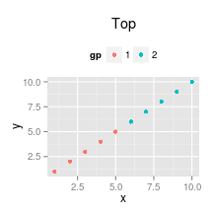

(b)

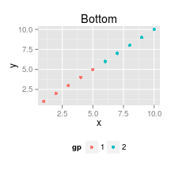

(c)

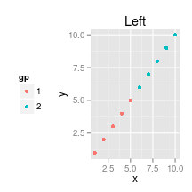

(d)

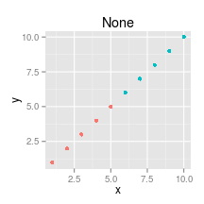

(e)

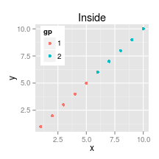

(f)

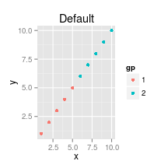

Answers:

a.

theme(plot.title=element_text(hjust = 0.5, size=rel(1.5), lineheight=.9, face="bold" ),

legend.position="top",

legend.title = element_text(face="bold"))

b.

p0 + ggtitle("Bottom") +

theme(plot.title=element_text(hjust = 0.5, size=rel(1.5), lineheight=.9, face="bold"),

legend.position="bottom",

legend.title = element_text(face="bold"))

c.

p0 + ggtitle("Left") +

theme(plot.title=element_text(hjust = 0.5, size=rel(1.5), lineheight=.9, face="bold"),

legend.position="left",

legend.title = element_text(face="bold"))

d.

p0 + ggtitle("None") +

theme(plot.title=element_text(hjust = 0.5, size=rel(1.5), lineheight=.9, face="bold"),

legend.position="None",

legend.title = element_text(face="bold"))

e.

p0 + ggtitle("Inside") +

theme(plot.title=element_text(hjust = 0.5, size=rel(1.5), lineheight=.9, face="bold"),

legend.position=c(.009,.99),legend.justification = c(0,1),

legend.title = element_text(face="bold"))

f.

p0 + ggtitle("Default") +

theme(plot.title=element_text(hjust = 0.5, size=rel(1.5), lineheight=.9, face="bold"),

legend.title = element_text(face="bold"))

1. Please use the DF1 data frame to draw following graphs, respectively. Write down the used functions in ggplot2 (25 points)

(a)

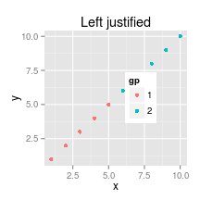

(b)

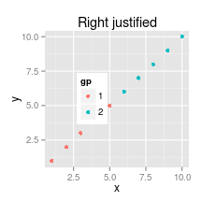

(c)

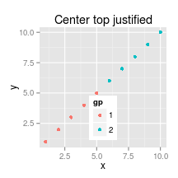

(d)

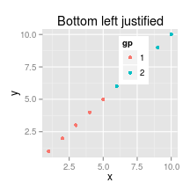

Answers:

a.

p0 + ggtitle("Left justified") +

theme(plot.title=element_text(hjust = 0.5, size=rel(1.5), lineheight=.9, face="bold"),

legend.position=c(.65,.6),legend.justification = "left",

legend.title = element_text(face="bold"))

b.

p0 + ggtitle("Right justified") +

theme(plot.title=element_text(hjust = 0.5, size=rel(1.5), lineheight=.9, face="bold"),

legend.position=c(.3,.6),legend.justification = "right",

legend.title = element_text(face="bold"))

c.

p0 + ggtitle("Center top justified") +

theme(plot.title=element_text(hjust = 0.5, size=rel(1.5), lineheight=.9, face="bold"),

legend.position=c(.45,.4),legend.justification = "top",

legend.title = element_text(face="bold"))

d.

p0 + ggtitle("Bottom left justified") +

theme(plot.title=element_text(hjust = 0.5, size=rel(1.5), lineheight=.9, face="bold"),

legend.position=c(.65,.7),legend.justification = c(0,0),

legend.title = element_text(face="bold"))